Contents

Proposed Profile: Device Clinical Bridge (DCB) 2

Scope and Goals 3

Scope Constraints 4

1. Cost Benefit 5

2. Key Use Case 5

3. Standards & Systems 6

4. Technical Approach 8

5. Support & Resources 19

6. Risks 19

7. Open Issues 20

9. Tech Cmte Evaluation 22

# Proposed Profile: Device Clinical Bridge (DCB)

* Sponsor: VHA
* Proposal Editor: Alex Lippitt
* Profile Editor: Ioana Singureanu
* Other Contributors: Greg Staudenmaier; Paul Schluter; Holly Miller, Catherine Hoang
* Domain: submitted to PCC

This work item is intended to start during the 2015/2016 IHE development cycle and it is in its planning phase. It is part of a larger effort:

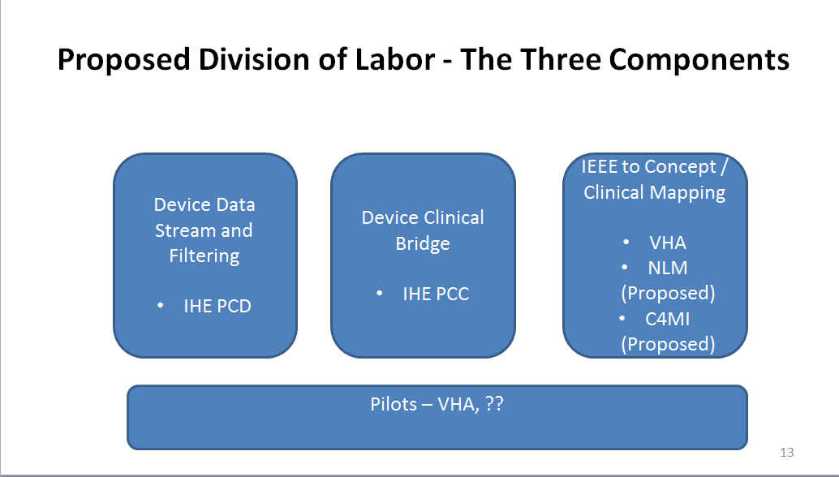

The key work in the IEEE to Concept / Clinical Mapping is now the subject of a soon-to-be-submitted proposal from the VHA to NLM for calendar year 2015 under VHA NLM MOU. The proposed work would be in multiple phases including evaluation of the proposed DCB use case and mapping between the almost 700 clinical ISO / IEEE11073 10101 terms in RTMMS with the relevant US sanctioned clinical vocabularies (LOINC, SNOMED and RXNORM) to find a pragmatic solution for aligning the nomenclatures both now and going forward.

Part of the challenge will be how to determine an international base and any need for US or other country/region extensions.

**The Problem**

The general rule today is that while a clinician or provider can view patient data generated by patient care devices in an inpatient setting or outpatient encounter room, but when that same person accesses his or her EHR application that data is not available. Getting semantically correct clinical data from patient care devices into clinical applications is generally not achieved today for a number of reasons:

* The applicable nomenclature from medical devices, IEEE 11073 10101, is not one of the Meaningful Use (MU) approved nomenclatures, reducing the incentive to use IEEE 11073 data in clinical applications. The update under review, IEEE 11073 10101a, is also not one of the MU approved nomenclatures.
* There are no commonly accepted mappings of IEEE 11073 10101 to Meaningful Use approved nomenclatures (LOINC and SNOMED primarily, some RxNORM) for clinical measures although there are vendors who have done so as proprietary interfaces.

Note: There are still many circumstances where the specific numeric measures are not codified in a generally accepted standard, for example the on-Going work with ventilators.

The result is that much of this numeric data generated from medical applications is either not reentered into clinical systems or reentered at significant risk of error. The result is that much of this numeric data generated from medical applications is either not reentered into clinical systems or reentered at significant risk of error.

This is also the case to a large extent for consumer patient care devices used in remote care where semantic work has been completed by HL7 and Continua involving SNOMED, but has not been included in an integration profile defining the input of this data into clinical applications.

### Scope and Goals

A list of primary DCB objectives is identified as follows:

* Define and include in VSAC or another standards-based repository or repositories clinical content consisting of “Device numeric export” for vital signs mapped to LOINC and SNOMED produced by Medical Devices
* Develop and approve an IHE International Integration Profile that facilitates consumption of medical device generated vital signs in clinical applications as an initial high impact proof-of-concept use case.
* As necessary support a US extension of the IHE international Integration Profile standard to permit usage of the Consolidated CDA and FHIR resources to facilitate easier consumption by EHRs in the US market.
* Include facilitation of clinical application related automatic access to alerts and events in a publish/subscribe model.
* Facilitate the saving of device numeric export for vital signs messages in repositories for usage in continuity of care, population management, accountable care and clinical research / quality improvement applications.

The project’s goals include:

* Establish an ongoing process to harmonize medical device and clinical nomenclatures; align change management and new release processes to provide HIT with a clear path to adapt changes
* Obtain approval to include this standard as a gap closer in the ONC Interoperability Roadmap; Work with ONC to align incentives to encourage implementation of the new standard in medical devices, as well as the standards usage in clinical care.
* Institutionalize where possible a closer working relationship between the medical device and clinical communities to develop and support compatible nomenclatures, and to stimulate innovation through better clinical knowledge about device capabilities and more impactful

### Scope Constraints

The proposed scope of the work is constrained by the following:

* Principles
  + - Avoid semantic transformation where possible; work with both nomenclatures to align terminology and value sets with each other (include whole chunks of 11073 10101 nomenclature where possible) – needs to merge into clinical realm; if the US is any example, government semantics standards focus is on the clinical end and that needs to be taken into account by the medical device domain
    - Use post-coordinated SNOMED concepts where possible to reduce the number of concepts that need to be created and managed; where necessary based on the IEEE 11073 10101 input
      * + Map pre-coordinated concepts and deal with multiple axes
        + Deal with multiple axes for complex concepts
  + IEEE overlaps SNOMED CT, LOINC, RxNorm, and UCUM terminology. Initially only the observation identifiers in LOINC (and perhaps SNOMED for constraints) would be addressed but in the future we will address the other areas of overlap. The principle of post-coordinated concept priority is a useful one
  + Establish an on-going process to ensure device / clinical harmonization over time involving IEEE, IHE, and hopefully NLM (with whom we are currently in discussion, planning for future VA/NLM inter-agency agreements
  + device / clinical harmonization over time involving IEEE, IHE, and relevant national and international semantic repositories
* Scope Deferred
* Use cases beyond inpatient vital signs, events and alerts
* Usage with consumer devices
* Usage with portable lab devices

## Cost Benefit

Benefits of the Device Semantic Bridge (DCB) integration would include:

1. Improved workflow: Medical device data desired for clinical, operations, clinical quality improvement, population and research purposes could be requested retrospectively or subscribed in advance for publishing to a repository or to a specific clinical application for a specific patient and intervention.
2. Improved data collection: Data would no longer need to be reentered from the device to the clinical application, effectively eliminating risks of neglecting to implement the data or making transcription errors.
3. Improved safety: Additional medical device observation data would be available to clinicians.
4. Improved patient care: Increased observation data would be included in the patient’s chart as well as in near real time for the clinical application for clinical decision support.

In the short term, the benefits would apply to a high volume of work including any inpatient scenario involving devices providing vital sign observations. This would only increase over time as outpatient and patient settings are added and observations are added beyond vital signs.

Vital signs benefits of course do not apply to those vital signs that are observed manually such as height.

## Key Use Case

There are a number of key use case examples, both inpatient and outpatient, all in the clinical environment. One use case was selected based on its relative simplicity in regards to semantic interoperability and also its high volume. That use case involves the monitoring of vital signs in an inpatient setting (ICU, Step Down, Observation, General / Surgical).

The patient is transported to a room and is attached to a monitor or monitors to collect the key vital signs as defined by US Meaningful Use as a minimum (this following could be a US extension version and there may be a different international version):

* Body Temperature
* BP Diastolic
* BP Systolic
* Head Circumference (manual entry)
* Heart Rate
* Height (manual entry)
* Height (Lying)
* O2 % BldC Oximetry
* Respiratory Rate
* Weight Measured

## Standards & **Systems**

Nomenclatures / Terminologies Used:

* Device (IHE PCD Technical Framework Volume 3 – Semantic Content)
  + IEEE 11073 10101 Nomenclature
  + MDC terms
* Clinical (HL7 Implementation Guide for CDA R2: IHE Health Story Consolidation, DSTU R1.1)
  + LOINC (observations)
  + SNOMED (constraints primarily)
  + RxNorm (anesthesia drugs)
  + UCUM (units of measure)
* Device Information Model (DIM) – how a device maps to a hierarchical, containment tree model – GMDN. MDNS assumed in use but being phased out

HIT Detail:

* *Messaging*
  + *HL7 V2.6 constrained by IHE DEC PCD-01 and RTM – Device Operations: Input*
  + *HL7 v3 CDA - Clinical Observations: Output\**

* Message Transport
  + *Minimum Lower Layer Protocol (MLLP) over TCP/IP – Device Operations*
  + *Web Services(REST/SOAP) - Clinical Observations*

* Systems Impacted
  + *EHRs primarily currently*
  + *Over time: Clinical Decision Support, Population Management, Clinical Research*

*\* FHIR impact anticipated with CDA migration to FHIR resource definitions in the future*

## Technical Approach

Data Content

The following describes the large scope of data in multiple phases in the first graphic and the vital sign only portion in the second two slides:

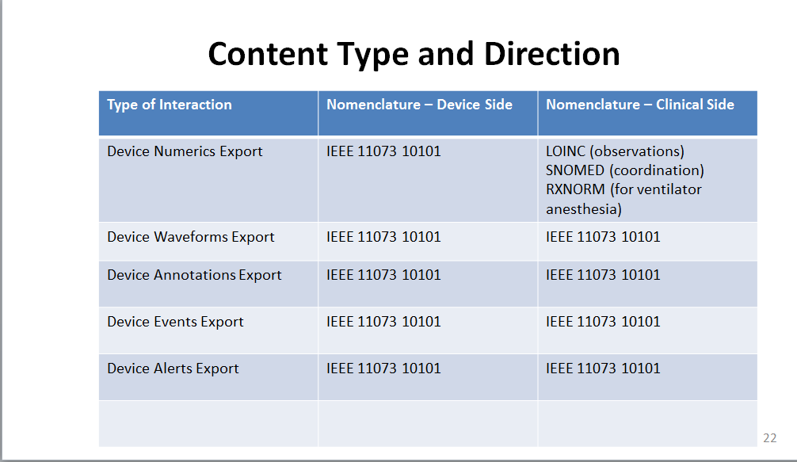

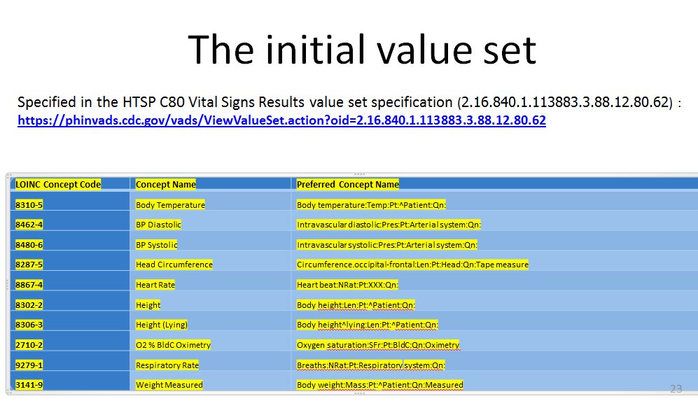

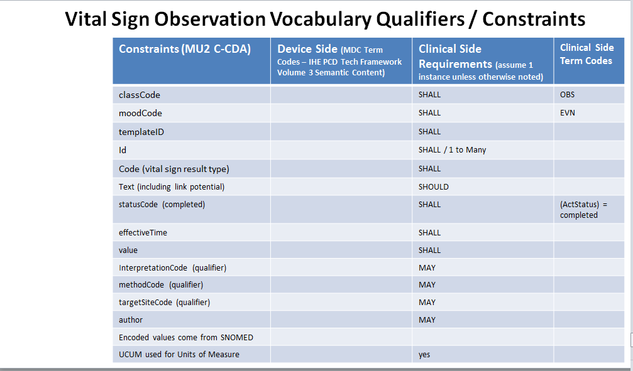

Existing related actors and in the current PCD workflow:

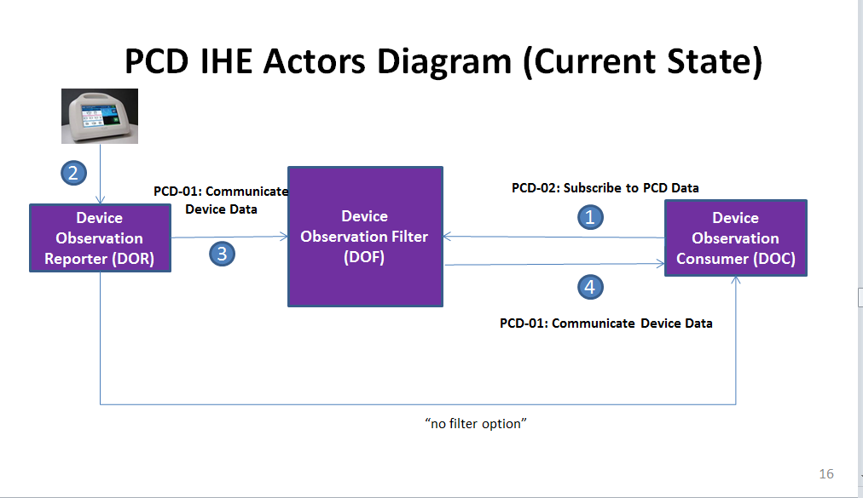

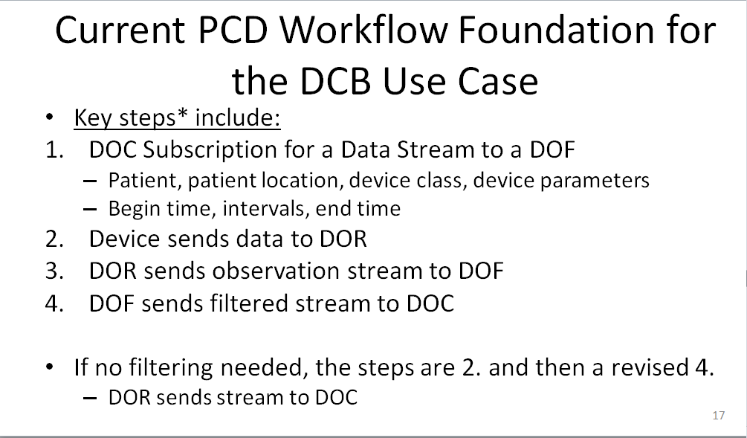

**Proposed actors and workflow**

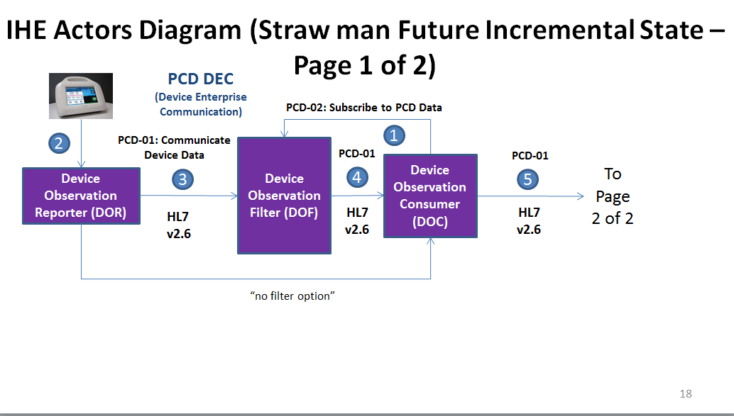

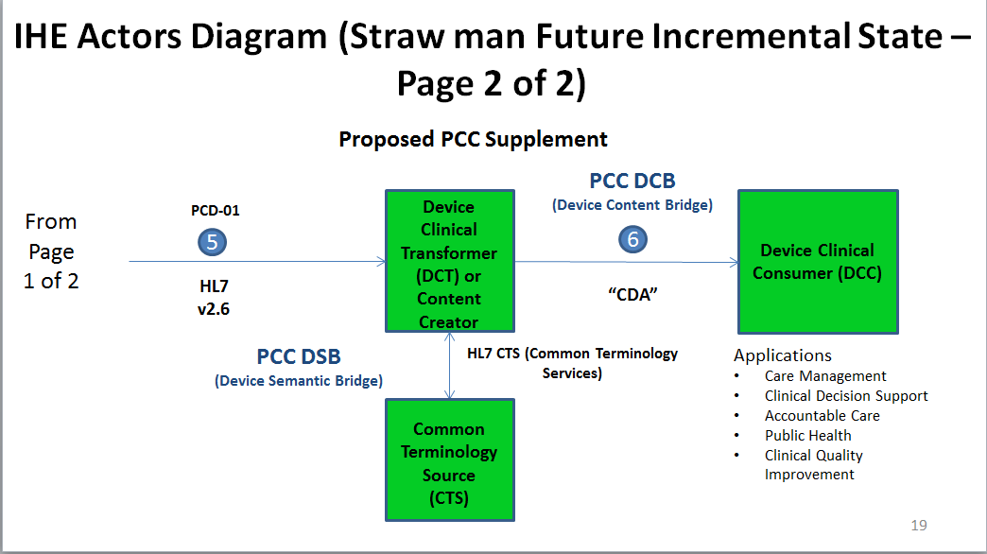

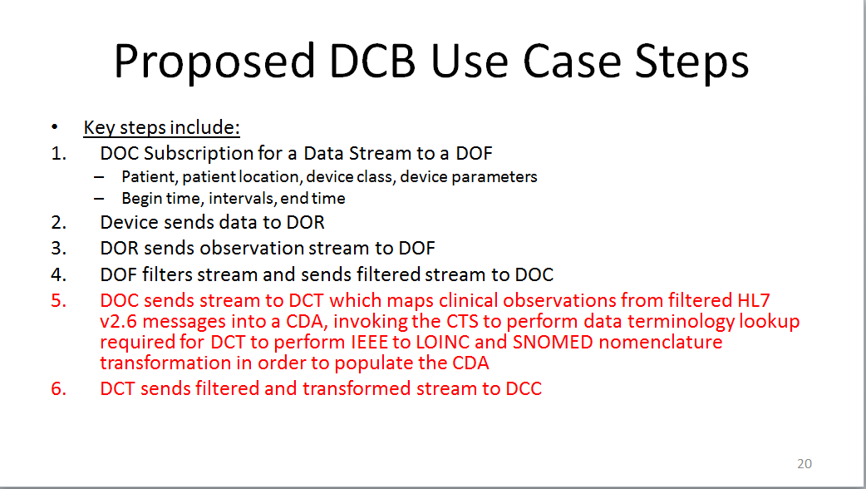

**Existing actors:**

**Device Observation Reporter (DOR):**

* Generate HL7 Device observation messages

**Device Observation Consumer (DOC):**

* Generate subscription requests for DOR output
* Generate pull queries (retrospective data)

**Device Observation Filter (DOF):**

* Configure from subscription requests
* Publish
* Respond to pull queries

New actors

**Device Clinical Transformer (DCT)**

* Manage transform process ; take in PCD-01 – output clinical version TBD

**Device Semantic Consumer (DSC)**

* Receive and consume device data in clinical nomenclature and IEEE native nomenclature as appropriate – generally an EHR, clinical decision support, remote monitoring, CQI, research, or continuity of care type application

**Device Clinical Converter (DCC)**

* Receive and consume device data in clinical nomenclature and IEEE native nomenclature as appropriate – generally an EHR, clinical decision support, remote monitoring, CQI, research, or continuity of care type application

**Existing transactions**

* PCD-01 Communicate Device Data
* PCD-02 Configure, and Subscribe to PCD Data – originally conceived to be Subscribe Only (used rarely)

**New Transactions**

* TBD to transform the existing PCD-01 payload into a payload that is consumable by

**Impact on existing integration profiles**

* PCD IHE International Integration Profiles for device interoperability with external systems
* DEC – Device Enterprise Communication – TBD
  + SPD – Subscribe to Patient Data – little use to date
  + Filtering – little use to date
* ACM – Alert Communication Management – TBD
* Device-specific Integration Profiles for implantable cardiac devices, infusion pumps and pulse oximetry - only pulse oximetry could be impacted in the first phase

**New integration profiles needed**

* DSB – Device Semantic Bridge
* DCB – Device Content Bridge

**Breakdown of tasks that need to be accomplished**

**Key initial technical scoping tasks:**

* TBD

**SME driven deliverables:**

* Data mapping into CDA
  + Metadata
  + Observation data
* Extension of vital sign template to contain additional vital signs as required; determination of whether these will be device generated or data entered
* Data transformation from IEEE 11073 10101 into LOINC and SNOMED nomenclatures where required
* Review of DEC filtering and configuration needed for clinical and retrospective data usage options and determination of gaps

## Support & Resources

**Collaborators (Phase 1)**

* VHA (Office of Informatics and Analytics (OIA), Healthcare Informatics (HI), Knowledge Based Systems (KBS) - Sponsored
* IHE International PCC Domain - Standards Integration Profile Development (proposed)
* IHE International PCC Domain – profile technical support, testing support, change proposal management as appropriate
* C4MI – Mapping and Technical Support (proposed)
* NLM – Mapping with subcontracts to IHTSDO and Regenstrief Institute as appropriate, (new/revised scope added to NLM/VHA Interagency Agreement (IAA))
* ONC – Endorsement Support / Inclusion in Roadmap (desired)
* IHE USA – Project Management / Secretariat / Implementation Committee Work Group Content Support

## Risks

* Inability to accurately transform certain vital signs from device to clinical system
* Solution additionally burdens clinician and/or system workflow

## Open Issues

| **Section** | **Num** | **Issue / Challenge** | **Discussion / Resolution** |
| --- | --- | --- | --- |
| 1 | 1 | * How will incentives be built in to gain willing compliance from device manufacturers and EHR vendors? * US Interop Roadmap? * US Meaningful use? * Health system purchasing requirements? * How will incentives be built in to gain willing compliance from device manufacturers and EHR vendors? * How can we best leverage market incentives? |  |
| 3 | 1 | What vital sign observations need to be added to create a truly based CDA document? |  |
| 5 | 1 | Should the standard be set up to provide the following web services options?   * REST * SOAP |  |
| 5 | 2 | * To what extent can clinical applications (e.g. EHRs, etc.) access required mappings in plug_and_play mode? * Will there be a service to permit real or near real-time data mapping and semantic transformation where required? * Will the mappings be available in machine readable form? * Will mappings be available in some form such that vendors can take advantage of their rich mapping utilities |  |
| 5 | 3 | Where will the “source of truth” mappings / data transformations be housed:   * RTMMS * VSAC * Other Option? |  |
| 5 | 4 | How will the mappings and data transformations be maintained? |  |
|  |  | To what extent will Continua mapping and transport/messaging be helpful for this project? |  |

1. Initial LOINC observation code mapping for CDA vital signs
2. Mapping the 600+ IEEE concepts that are in use by PCD adopter to LOINC
3. Mapping IEEE units of measure to UCUM
4. Mapping IEEE drug codes to RxNorm

Mapping IEEE qualifier codes to SNOMED

## 9. Tech Cmte Evaluation

*<The technical committee will use this area to record details of the effort estimation, etc.>*

Effort Evaluation (as a % of Tech Cmte Bandwidth):

* 35% for ...

Responses to Issues:

*See italics in Risk and Open Issue sections*

Candidate Editor:

TBA